* + - * 1. **Use-Case Diagram**

A use case is a set of scenarios that describes an interaction between users and the system. A use case diagram displays the relationship among actors and use cases. The two main components of use-case diagram are user cases and actors.

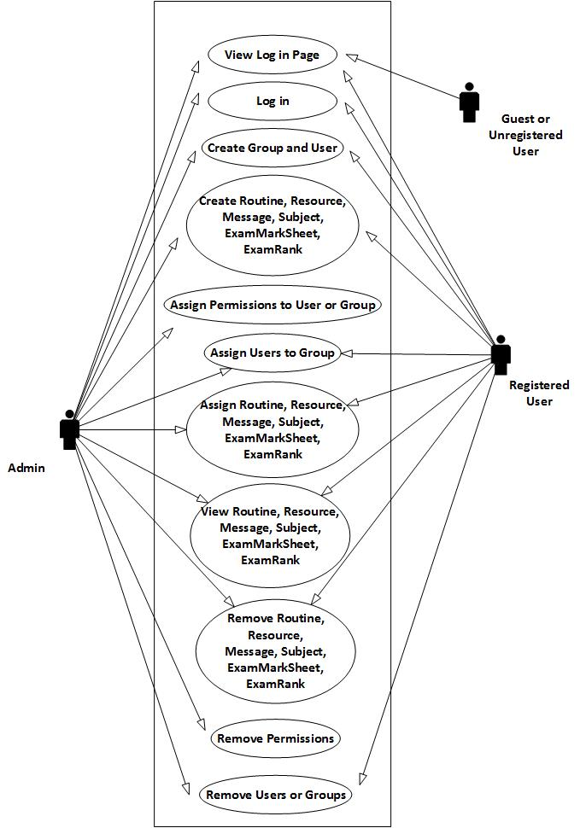

Fig 5.15: Use-Case Diagram of CIMS

5.2.2.4 Interface Design

The interface design in another important aspect that needs to considered during the program development because the interface is the main user interaction section that the user of the program uses for their convenience purpose of the data entry and the handling of the software.

5.3 Module Level Design

While designing modules, “Co-operative Management System” has been considered as having independent module concept. Any module has no dependency with data of programming and configuration along with database system. This concept reduces the error raise on transit period of switch in modules and running modules independently.

5.4 Conclusion

Hence the development of the system always starts with the establishment of the environment system that shows the operating system require and the system considered for the development and running of the system. Different object Oriented Programming tools have been incorporated during the accomplishment of this project that eased the project development to greater extent.

# CHAPTER 6: SYSTEM DEVELOPMENT

6.1 Website Development

A website may be the work of an individual, a business or other organization and typically dedicated to some particular or organizational topic and purpose, any website can contain a hyperlink to any other website.

A website is hosted on a computer system known as a web server, also called HTTP server and these terms can refer to the software that runs on these systems and that retrieves and delivers the Web Pages in response to request from the website users.

A dynamic website is one that has frequently changing information or interacts with the user from various methods or direct interaction. There is a wide range of software systems such as Active Server Pages, Java Server Pages and PHP programming language that are available to generate dynamic web systems and dynamic sites. Sites may also include content that is retrieved from one or more databases or by using XML-based technology such as RSS.

In our project, we have used Active Server Page (APS.NET) and SQL Server. We have used C# as programming language for styling, we have used Bootstrap with HTML 5 & CSS 3.

6.2 Web Server/Clients

A web server houses web objects, each addressed by a URL. Web servers also implement the server side of HTTP. A web server typically contains documents that it servers to its client. These documents are called web pages. A web page consists of objects. An object is simply a file such as HTML, File, JPRG image, GIF image, a Flash document, an audio clip and so on-that is addressable by a single URL.

Most web pages consist of a base HML file and several referenced objects. For example, if a web page contains HTML text and five JPEG images then the web page contains six objects. The base HTML file references the other objects in the page with the object’s URLs. Popular web servers include Apache and Microsoft IIS.

A browser is a user agent for the web. It displays the requested web page and provides numerous navigational and configuration features. Web browsers also implement the client the client side HTTP. Thus, in the context of the web, the term ‘Browser’ and ‘Client’ are interchangeably used. Popular web browsers include Netscape Communicator, Microsoft Internet Explorer, Mozilla fire Fox, Google Chrome, etc.

6.3 Tools Used

For accomplishing the system development different tools are uses:

* 1. Microsoft Visual Studio 2013
  2. .NET Framework 4.0
  3. ASP.NET MVC 5
  4. Microsoft Visual C#
  5. Microsoft SQL Server
  6. IIS
  7. JavaScript
  8. Bootstrap with HTML5 and CSS3
  9. AJAX
  10. Adobe Photoshop
  11. Microsoft Visio 2013

6.4 System Maintenance

System maintenance is the enigma of system development. It holds the industry captive trying up programming resources. System maintenance follows the conversion to the extent that changes are necessary to maintain satisfactory operation relative to changes in the users’ environment. Maintenance often includes minor enhancements for corrections to problems that surface late in the system’s operation. Analyst and programmer spend far more time maintaining program that they do writing them. Maintenance accounts for 50-80 percent of the total system development.

Maintenance can be classified as corrective, adaptive or perfective. Corrective maintenance means repairing processes or performance failures or making changes because of previously uncorrected problems or false assumption. Adaptive maintenance means changing the program function. Perfective maintenance means enhancing the performance or modifying the programs to response to user’s additional needs.

6.5 Conclusion

Thus for the project development process, various software and platform are needed and that requirements are fulfill using the most reliable and the happening software in the world’s market. The different technologies such as, Ajax has also been incorporated.

# CHAPTER 7: SYSTEM TESTING

System testing is the process of testing the software that has been developed by the process that gone through analysis, design a development. It includes well-defined steps result in the successful construction of the software. A software testing strategy should be flexible enough to promote a customized approach. At the same time, it must be rigid enough to promote reasonable planning and management tracking as the project progresses.

7.1 White Box Testing

White box testing is a text case design method that uses the control structure of the procedural design to derive test cases. White box testing of software is predicted on close examination of procedural details. Logical paths through the software are tested by providing test cases that exercise specific set of conditions and loops. White box testing focuses on the program control structures.

The programmer and designer test the logic of the modules of program. Through this testing the execution of each and every statement and checking condition of all decision paths within the logic of individual modules are found to be perfectly working with only few exceptions. Control and data flow was clear. From this test, we derived at the following test cases:

1. Guarantee that all independent paths within the module have been exercised at least once.
2. Exercise all logical decisions on their true and false sides.
3. Exercise all loops at their boundaries and within their operational bounds.

7.2 Black Box Testing

Black box testing focuses on the functional requirements of the software. It is a user acceptance testing that has the objective of telling on the validity and the reliability of the system.

Black box testing is not an alternative to white box testing rather it is a complementary approach that is likely to uncover different class of error than white box testing. This black box testing, also called the behavioral testing ensured the functional requirements of the software. From this test, we derived at the following test cases:

1. Incorrect or missing functions.
2. Interface errors.
3. Errors in dare structures or external data base access.
4. Behavior or performance errors.
5. Initialization and termination errors.

7.3 Conclusion

Thus, after all the testing we are able to correct the errors and small mistakes that had previously been unseen and thus, we can improvise and/or figure out some other way to carry out tasks that had been troubling.

# CHAPTER 8: IMPLEMENTATION

A crucial phase in the system’s life cycle is the successful implementation of the new system design. Implementation simply means converting a new system design into operation. A critical factor in conversion is not disrupting the functioning of an organization. In system implementation, a ‘help’ screen can provide a good start on the system.

8.1 System Evaluation

Every system requires periodic evaluation after implementation. A post-implementation review measures the system testing, which determines where the system fails so that the necessary adjustments can be made a post-implementation review determines how well the system continues to meet the performance specifications. It is the fact-after design and conversions are complete. It also provides information to determine whether major redesign is necessary.

8.2 Support

The software will undoubtedly undergo change after it is delivered to the customer. Change will occur because errors have been encountered, because the software must be adopted to accommodate changes in its external environment, or because the customer require functional or performance enhancements, Software support/maintenance reapplies each of the preceding phases to and existing program rather than the new one.

8.3 Conclusion

Hence, the successful implementation was possible without any hindrance. However, the software will be changed later to catch up with the demand of the users and ease.

# CHAPTER 9: LIMITATIONS AND FUTURE ENHANCEMENT

As no machine is 100% efficient likewise no task or project is ever performed without limitations. Similarly, our project also moved to many obstacles even critical situations were faced which compelled us to leave some limitations. The following are the limitations of our project:

1. Not polished UI.
2. No dedicated mobile app.
3. No support for features like library management and financing.
4. Lack of complete inclusion of functions to handle overall flows of any organizations especially colleges.

# CHAPTER 10: CONCLUSION

Finally, we have successfully completed the project entitled “CIMS”, conducted as a final year project of BE Computer fulfilling the target we specified in the proposal.

This project is the application of website development, managing online information flow among the students, teachers and managerial staffs. The project was thoroughly completed form the preliminary Investigation phase to Implementation phase. The project illustrates deep to the knowledge that we have gained from the courses like VB.Net/ C# programming, Software Engineering, Database Management System, & Information System and Design.

Hence, this project succeeds to nullify the problem available in the organization or colleges educational flows.

# CHAPTER 11: REFERENCES

1. https://www.codecademy.com/courses/web-beginner-en-yjvdd/0/1/2015-Oct-28/10:25am
2. <http://www.asp.net/mvc/overview/older-versions-1/overview/asp-net-mvc-overview/2015-Oct-30>/5:40pm
3. http://ajax.net-tutorials.com/controls/updatepanel-control/2015-Nov-1/12:40pm
4. <http://www.w3schools.com/aspnet/mvc_intro.asp/2015-Nov-6>/3:35pm
5. http://www.drdobbs.com/tools/microsoft-visual-studio-2013-review/240163830/2015-Nov-11/3:55pm
6. http://www.tutorialspoint.com/bootstrap/2015-Nov-11/4:15pm

# Appendix

1. List of Figures

Fig 2.1: Microsoft Visual Studio Professional 2013

Fig 2.2: .Net Framework

Fig 2.3: MVC model

Fig 2.4: Bootstrap with HTML 5 and CSS 3

Fig 2.5: Microsoft Visio Professional 2013

Fig 2.6: RAD Model

Fig 3.1: Architecture of CIMS

Fig 5.1: Gantt Chart of CIMS

Fig 5.2: Context Diagram

Fig 5.3: Group 1-Level DFD diagram

Fig 5.4: Message 1-Level DFD diagram

Fig 5.5: Message Interaction 1-Level DFD diagram

Fig 5.6: Permission 1-Level DFD diagram

Fig 5.7: Resource 1-Level DFD diagram

Fig 5.8: Routine 1-Level DFD diagram

Fig 5.9: Subject 1-Level DFD diagram

Fig 5.10: User 1-Level DFD diagram

Fig 5.11: Flowchart -1 (Super Admin)

Fig 5.12: Flowchart-2 (Admin)

Fig 5.13: Flowchar-3 (User)

Fig 514: ER Diagram of CIMS

Fig 5.15: Use-Case Diagram of CIMS

2. List of Abbreviations

CIMS - College Information Management System

VS - Visual Studio

IIS - Internet Information Service

AJAX - Asynchronous JavaScript and XML

SDLC - System Development Life Cycle

OOP - Object Oriented language

[HTTP](https://en.wikipedia.org/wiki/HTTP) - Hypertext Transfer Protocol

[HTTPS](https://en.wikipedia.org/wiki/HTTPS) - Hypertext Transfer Protocol Secure

[FTP](https://en.wikipedia.org/wiki/File_Transfer_Protocol) - File Transfer Protocol

[FTPS](https://en.wikipedia.org/wiki/FTPS) - File Transfer Protocol over Secure Sockets Layer

[SMTP](https://en.wikipedia.org/wiki/Simple_Mail_Transfer_Protocol) - Send Mail Transfer Protocol

[NNTP](https://en.wikipedia.org/wiki/Network_News_Transfer_Protocol) - Network New Transfer Protocol

WPF - Windows Presentation Foundation

WCF - Windows Communication Foundation

WF - Workflow Foundation

WinRT - Windows Runtime

ALM - Application Lifecycle Management

XAML - Extensible Application Markup Language

UI - User Interface

API - Application Programming Interface

MVC - Model-View-Controller

ASP - Active Server Pages

iOS - iphone Operating System

CLR - Common Language Runtime

XML - Extensible Markup Language

XSLT - Extensible Stylesheet Language Transformations

HTML - Hypertext Markup Language

XHTML - Extensible Hypertext Markup Language

CSS - Cascading Style Sheets

ECMA - European Computer Manufacturers Association

ISO - International Organization for Standardization

SQL - Structured Query Language

ANSI - American National Standards Institute

NT - New Technology

CMYK - Cyan, Magenta, Yellow and key (black)

PSD - Photoshop Document

PSB - Photoshop Big

3. Screenshots

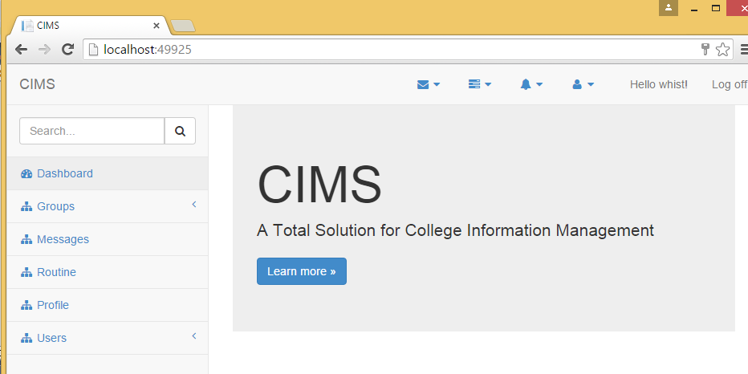

Fig (i): Screenshot – 1 (Dashboard)

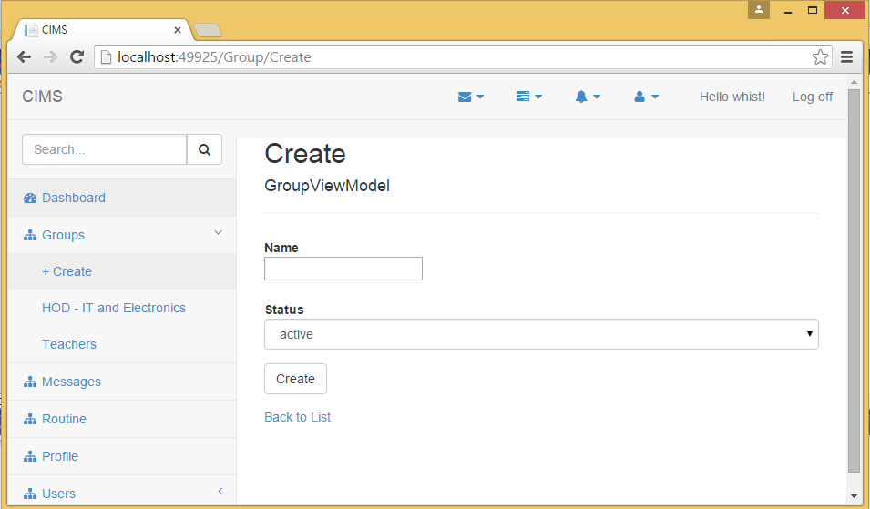

Fig (ii): Screenshot – 2 (Group create form)

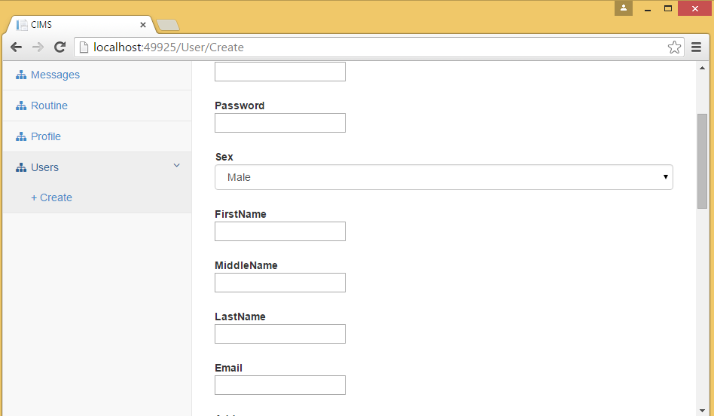

Fig (iii): Screenshot – 3 (User create form)

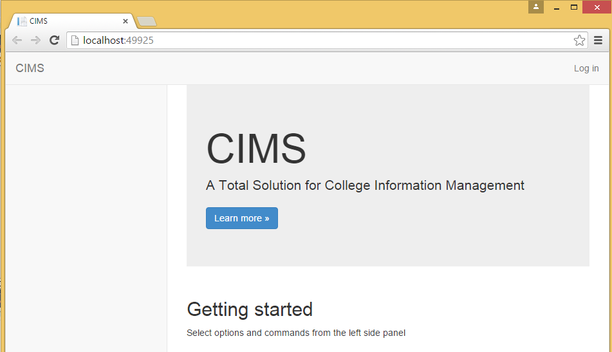

Fig (iv): Screenshot – 4 (Log in page)

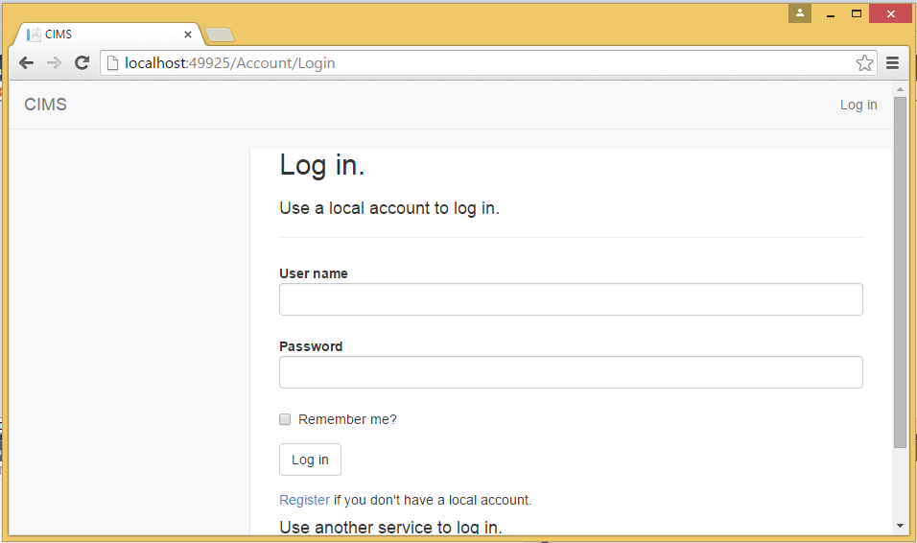

Fig (v): Screenshot – 5 (Admin log in page)